Target: Journal of Agricultural and Food Chemistry

**Determination of geographical origin by multi-elemental profiling combined with machine learning techniques: a study on Chinese geographical indication (GI) rice**

Fei Xu1, Fanzhou Kong1, Hong Peng1, Shuofei Dong2, Weiyu Gao1, Guangtao Zhang1*

1Mars Global Food Safety Center, Beijing 101407, China

2Agilent Technologies (China) Co., Ltd, Beijing 100102, China

*Corresponding author: Tel.: +86 13331152657. E-Mail: [Guangtao.zhang@effem.com](mailto:Guangtao.zhang@effem.com)

**ABSTRACT**

The demand for geographical indication (GI) rice has increased amongst Chinese consumers, which potentially results in a high risk of adulteration due to its high value and limited production. This study aims to develop a novel strategy of non-targeted data analysis to determine geographical origins of Chinese GI rice based on multi-elemental profiling obtained by inductively coupled plasma mass spectrometry (ICP-MS). 131 samples from six types of Chinese GI rice were analyzed. Coupled with feature selection (relief algorithm), two machine learning based classifier, support vector machines (SVM) and random forest (RF) were utilized to predict the origins of GI rice; the results were validated through repeated grid-search cross-validation. For both SVM and RF, four elements (Na, Al, Cd, and Rb) only could enable the prediction with 100% accuracy. These results demonstrate the feasibility of ICP-MS combined with machine learning techniques as an effective strategy for authentication of GI rice in China.

KEYWORDS

TBC

**INTRODUCTION**

In the current world of globalization, geographical authentication of food materials has emerged as an important issue, which is crucial for both quality assurance and food safety1. The notion of geographical indication (GI) first originated from the 19th century in Europe, with the purpose of protecting industrial property rights2. Nowadays, product with GI certification generally possess a given quality, reputation or other characteristics attributable to geographical origins3, thus making it possible for them to be differentiated from competitors’. According to the European Union (EU) quality schemes, three different systems have been enforced to protect the origin integrity of agroproducts and food: protected designation of origin (PDO), protected geographical indication (PGI) and traditional specialties guaranteed (TSG)4. Currently in China, State Administration for Industry and Commerce/ the Trademark Office (SAIC/TMO), the General Administration of Quality Supervision, Inspection and Quarantine (AQSIQ), and the Ministry of Agriculture (MoA) are supervising and protecting GIs from different aspects or direction, at the administrative level5.

Rice (*Oryza sativa L.)* is among the world’s top three largest food crops and is a staple food for nearly 50% of the world population. China is leading in the rice paddy production in the world, with 214.4 million metric tons in 20176. With the increasing living standard, there is a growing demand domestically for rice with traceable origins7. For example, Wuchang rice, one of GI rice produced in Heilongjiang Province in China’s northeast region, is known for its superior quality and unique sensory characteristics. Due to the gap between the limited production and high market demand, the price of Wuchang rice is roughly twice than that of other domestic rice, making it vulnerable to adulteration such as partial substitution and fraudulent labeling8,9. Therefore, determination of geographical origins of rice is of great importance to protect the rights of farmers, retailers and consumers3.

Since it is challenging to accurately distinguish rice from different origins via visual inspection, multiple “fingerprinting”-based approaches have been developed in recent years. For example, vibrational spectroscopy-based techniques such as Raman spectroscopy10 and near-infrared (NIR) spectroscopy11,12 have been utilized to differentiate rice with different origins. Notably, multi-elemental profiling by inductively coupled plasma mass spectrometry (ICP-MS)13–15 and stable isotope ratio analysis have already been successfully employed to authenticate the geographical origins of rice. As been summarized in a recent review, principle component analysis (PCA) combined with linear discriminate analysis (LDA) is by far the dominant strategy for rice authentication, thanks to its simplicity and ability in detecting hidden information in data16. Furthermore, there is an emerging trend of utilizing machine learning techniques to achieve the goal of rice discrimination. Support vector machines (SVM)14, decisions trees, random forest (RF) and artificial neural network (ANN)17 are the most popular ones found in recent studies.

The aim of this study was to determine the geographical origins of six different Chinese GI rice basing on their multi-elemental profiling obtained by ICP-MS. Particularly, a novel machine learning based workflow was implemented by combining feature selection (relief algorithm) and supervised classification (i.e. SVM/ RF algorithms).

**MATERIALS AND METHODS**

*Rice samples*

Proper sampling is fundamental for achieving reliable results from multivariate model building18. In this study, a total of one hundred and thirty-one Chinese GI rice samples were directly collected from paddy fields from five provinces (i.e. Heilongjiang, Liaoning, Jiangsu, Hubei and Guangxi). For simplicity’s sake, we named those GI rice as WC, GG, PJ-1, PJ-2, JS, and SY. An overview of acquired rice sample distribution is shown in Fig. 1.

*Reagents and chemicals*

Nitric acid (HNO3, 69%, part# 100441) were purchased from Merck Millipore (Darmstadt, Germany). Deionized water (18.3MΩ cm) was obtained from a Milli-Q system (Millipore, MA, USA). Multi-element calibration standard 2A (part# 8500-6940), 4 (part# 8500-6942), Environmental calibration standard (part# 5183-4688) and Scandium standard (part# 5190-8578) were purchased from Agilent Technologies (Santa Clara, CA, USA).

*Sample digestion and ICP-MS analysis*

In order to minimize the impact of unexpected contamination, the Teflon digestion vessels were soaked in 30% (v/v) nitric solution for 24h, and then rinsed with deionized water for three times before use. For pre-digestion procedure, 0.5 g of rice grains was directly digested in duplicate in digestion vessels with 6mL of concentrated HNO3 and left in fume hood overnight. The vessels were then placed in microwave oven (Anton Paar, Austria) next day. The digestion procedure was programed so that the temperature will gradually reach 180 °C in 15 min, and then kept at such temperature for 20 min. The digestion was completed when the sample solution mixtures turned into clear liquid. All solutions were cooled down at room temperature and diluted into 50mL metal-free plastic tubes. An Agilent 7900 ICP-MS (Agilent technologies, Santa Clara, CA, USA) was utilized for multi-elemental profiling. The instrumental setting and operative conditions were adopted from a previous study19 with modifications (RF power of 1550 W, RF matching of 1.85 V, , and carrier gas flow rate of 1.05 L·min-1). In this study, the concentrations of 30 elements (10B, 23Na, 24Mg, 27Al, 39K, 43Ca, 45Sc, 48Ti, 51V, 52Cr, 55Mn, 56Fe, 59Co, 60Ni, 65Cu, 66Zn, 70Ga, 73Ge, 75As, 78Se, 85Rb, 86Sr, 93Nb, 98Mo, 107Ag, 114Cd, 133Cs, 138Ba, 201Hg, 208Pb) in rice was detected. The internal standard solution of 103Rh (10 mg· L-1, part# 8500-6945) was also obtained from Agilent Technologies. One certified reference material of rice flour (1568b) from the National Institute of Standards and Technology (Gaithersburg, MD, USA) was used to verify the accuracy of the analysis method.

*Statistical analysis*

One-way analysis of variance (ANOVA) was carried out to access the statistically significant differences in the element contents of different GI rice (P ≤ 0.05). Raw data was first scaled by taking logarithmic transformation and then subjected to unsupervised PCA, which served as an initial step to visually uncover hidden information. Two machine learning algorithms, RF and SVM were implemented for the construction of classifiers with all six types of GI rice. RF was first introduced by Breiman20 and it is made of a collection decision trees, which are generated from original dataset using bootstrap partition. SVM makes classifications by projecting the input vectors into a high dimensional space, and finding a hyperplane that could separate different classes21. For feature selection, ReliefF22,23 was utilized to determine how much each feature is contributing to the overall classification.

The 131 samples were split in a stratified fashion (80:20) into a training set (n=104) and a testing set (n=27). The ReliefF algorithm was used to rank the features and applied only to the training set to avoid selection bias (e.g. over-optimistic prediction)24. Following this, a 10-fold grid-search cross-validation (citation) was conducted on the training set to obtain optimal classifiers, specifically: forward selection (citation) was conducted to select features that have been pre-ranked by ReliefF, and it only stops when the adding of features makes no contribution to the improvement of prediction accuracy; in the meantime, all possible combinations of the hyperparameters were tested25. Eventually, the optimal classifiers generated were independently validated on the testing set. Figure 2 demonstrated the pipeline we used for the training of classifier and validation of classification model.

All analyses were carried out by R (R Core Team, 2019), RStudio (v3.5.1, Boston, MA, USA) and Python (v3.7, Python Core Team) with additional packages: dplyr (R)26, factoextra (R)27, FSelector (R)27, sklearn (Python), skrebate (Python), numpy (Python) and pandas (Python).

**RESULTS AND DISCUSSION**

*Elemental concentration in Chinese GI rice*

Table 1 shows the mean values and standard deviations of 30 targeted elements from six GI rice in this study. Particularly, ANOVA and Tukey HSD test were conducted to determine the statistical significance. The validation of accuracy was conducted with SRM (1568b), and measured concentration agreed well with the certified values (Fig S1). Overall, except for the element of 208Pb, significant differences could be observed among all elements across six GI rice. However, based on the information obtained from ANOVA, it was impossible to identify element(s) that can directly differentiate all types of rice.

*Principle component analysis (PCA)*

In order to get an initial overview of the entire dataset, an unsupervised PCAwas conducted (95% confident ellipses included). As shown in Fig 2a, there was a clear separation pattern among PJ-1, GG and the rest of GI rice. while for JS, PJ-2, SY and WC, no satisfactory separation could be achieved based only on the 1st and 2nd principle component (PC). The loading plot (Fig 2b) showed that 27Al, 70Ga, 93Nb,51V, and 48Ti primarily contributed to the variations on PC1, while 23Na, 45Sc, 85Rb, 133Cs, and 114Cd contributed to both PC1 and PC2. For PJ-1 and PJ-2, even though from the same geological origin, they can still be clearly separated apart, with 27Al, 70Ga, 51V, and 45Sc showed significant difference among the two (Fig 2a& 2b). This may be related to the notion that rice discrimination remains a complex issue, since that not only geographical conditions but the cultivar type may play important roles13. In general, the first two PCs explained 60.7 % of the entire variances; by including the 3rd and 4th PC, nearly 85% of the total variances can be explained then (Fig 2c).

*Determination of geographical origin*

Fig 4 showed relative importance of the features ranked by Relief algorithm on the training set. Al, Rb, B and Na were the top four elements that contributed the most to the overall classification for six GI rice. As stated earlier, a 10-fold grid search cross validation was used to obtain the optimal classifiers. Specifically, as shown in Fig 5, with only one selected feature, RF achieved 48% of mean cross-validation accuracy, while SVM can reach up to 63%. The performances of both RF and SVM were boosted with more features been added. Eventually, both algorithms reached 100% training accuracy with only four features (Al, Rb, B, and Na), when optimal hyperparameters were also applied. Ultimately, the optimal classifiers generated were utilized for model validation on the testing set. The independent validation results could be found in table 2, where kappa coefficient is a statistic for testing interrater reliability (citations). Using both classifiers showed perfect classification results for all types of GI rice with 100% accuracy. The result suggested the information from these four elements has significant differentiation power to make the classification. With the information above, we further plotted the relative concentration of four elements in Radar plot. As shown Fig x (radar), each GI rice possessed its unique elemental pattern… By far, it is still challenging to elucidate the rationale why these four elements are showing such strong differentiation power in this study. Very likely that the complexity is due to the fact that we covered samples from all three dominate rice producing regions in China: the Northeast China plain (WC, PJ-1, and PJ-2), Yangtze River Basin (SY, JS), and southeast coastal region (GG). Particularly, the paddy soil in northeastis known for being more fertile and richer in organic matter than other regions in China (citation) and therefore rich in trace metal elements. ~~As we have observed, WC rice from Heilongjiang province is higher in Rb concentration indeed. The accumulation of elements in rice involves multiple factors (genotype, geographical conditions, meteorological characteristics, etc..).~~

*PJ-1 vs PJ-2: multiple factors may lead to different elemental distribution in rice*

In fact, the characteristics of paddy soils may not be the only factor determining the elemental accumulation in rice. In this study, PJ-1 and PJ-2, two genotypic differed rice yet harvested in almost identical geographical region, showed very different elemental distribution pattern. Particularly, they show very different profiles of Al and Na, ~~indicating other factors must play prominent roles as well~~. ~~A more comprehensive metadata would be helpful to better understand the origin of these high discrimination power~~. Multiple studies demonstrated that the rice genotype also plays an very important role in determine the level of metals accumulated in rice grains28,29

*Cd as key indicator to differentiate rice from southeast coastal region of China*

Among the 30 elements we have analyzed in this study, special attention was paid to 114 Cd, which is a known carcinogenic contaminate. According to a recent study conducted by Maione et al., the level of Cd alone can be used to differentiate rice from two Brazilian regions with satisfying accuracy14. In nowadays China, where rapid industrialization and urbanization are happening nationwide, the issue of heavy metal contamination for arable soil has been seen as emergent issue to be addressed. A national scale study revealed that Cd concentrations in paddy soils from different Chinese regions varied significantly, with the southeast coastal regions (e.g. Hunan, Guangxi) having the highest levels30. This is greatly due to the soil characteristics (i.e. low pH) as well as pollutions result from human activities (e.g. mining)30. As one of the subjects in this study, the GG rice were harvested from Guangxi Zhuang Autonomous region. As shown in Fig 5, the concentration of Cd itself was sufficient to differentiate GG rice from other five non-GG rice. This finding not only agreed with previous reports on the national Cd distributions, even more importantly, it provided the possibility that the level of Cd as a unique “marker” for GG rice.

***Table 3是否是提供Figure 5 的基础数据来源？如果是，是否有单独存在的必要？***

Our study demonstrated that multi-elemental profiling by ICP-MS, coupled with machine learning technique, can differentiate six Chinese GI rice with extremely high accuracy. Particularly, we have identified several elements with the most differentiating power. This opens the door for future study on whether measuring only a handful of elements could lead to reliable rice classification. Yet we are fully aware of the complexity of the task, since the elemental profile of crops may be simultaneously determined by multiple factors, for example, genotype, soil characteristics, climate, and agricultural practice31,32. As been pointed out by other researchers, sample scarcity along with lack of sample representativeness are major reasons leading to poor or unreliable classification33. In this study, only 131 samples from six different GI rice within one year of harvest were analyzed. Therefore, a larger dataset (both training and validation) consists of samples from multiple harvest years shall be introduced in the future, which will increase the reliability as well as the robustness of the classification model. In addition, considering the ultimate goal is to protect high value GI rice from potential fraudulent activities, it is of great importantce that we also introduce “positive” samples into the classification. One common solution is to dilute GI rice samples with serial does of highly “like-alikes”34 . Given the possibility that there may be certain levels of correlation among the concentrations of different elements, traditional univariate data analysis methods was not suitable for discrimination31, 35. As one of few attempts by far to apply machine learning strategy to process multi-elmental data, we have successfully established a workflow for … from the traning of classifers to model validation. Further work will be conducted to develop a simple, rapid yet reliable strategy for rice classification/ authentication.

**ACKNOWLEDGMENT**

We want to thank Dr. Di Wu from Yangtze Delta Region Institute of Tsinghua University for his tremendous support on sampling coordination. We thank Ms. Si Lin for her work on sample preparation. We also appreciate Dr. Peter Markwell for valuable suggestion on the preparation of the manuscript.

**FUNDING SOURCES**

**TBC**

**REFERENCE**

1. Drivelos, S. A. & Georgiou, C. A. Multi-element and multi-isotope-ratio analysis to determine the geographical origin of foods in the European Union. *TrAC - Trends Anal. Chem.* **40**, 38–51 (2012).

2. Summary of the Paris Convention for the Protection of Industrial Property (1883). Available at: https://www.wipo.int/treaties/en/ip/paris/summary_paris.html.

3. Luykx, D. M. A. M. & Ruth, S. M. Van. Food Chemistry An overview of analytical methods for determining the geographical origin of food products. **107**, 897–911 (2008).

4. PDO and PGI Agricultral products:a 14.2 billion euro turnover for over 800 products. Available at: https://ec.europa.eu/agriculture/quality/schemes/newsletter-2010_en.pdf.

5. Li, Y. Protection of Geographical Indications in China. (2017). Available at: https://www.niuyie.com/protection-of-geographical-indications-in-china/.

6. FAOSTAT 2017. Available at: http://www.fao.org/faostat/en/?#data/QC.

7. Jin, S., Zhang, Y. & Xu, Y. Amount of information and the willingness of consumers to pay for food traceability in China. *Food Control* (2017). doi:10.1016/j.foodcont.2017.02.012

8. Veeck, G. Food Safety Concerns and Rice Imports in China : 1998 - 2016. (2017).

9. Qian, L. *et al.* Determination of geographical origin of wuchang rice with the geographical indicator by multielement analysis. *J. Food Qual.* **2019**, (2019).

10. Zhu, L. *et al.* Identification of rice varieties and determination of their geographical origin in China using Raman spectroscopy. *J. Cereal Sci.* **82**, (2018).

11. Mertens, B. J. A. & Thompson, M. The authentication of Basmati rice using near infrared spectroscopy. (1993). doi:10.1255/jnirs.8

12. Pettinger, B., Ren, B., Picardi, G., Schuster, R. & Ertl, G. Tip-enhanced Raman spectroscopy (TERS) of malachite green isothiocyanate at Au(111): Bleaching behavior under the influence of high electromagnetic fields. *J. Raman Spectrosc.* **36**, 541–550 (2005).

13. Cheajesadagul, P., Arnaudguilhem, C., Shiowatana, J., Siripinyanond, A. & Szpunar, J. Discrimination of geographical origin of rice based on multi-element fingerprinting by high resolution inductively coupled plasma mass spectrometry. *Food Chem.* **141**, 3504–3509 (2013).

14. Maione, C., Batista, B. L., Campiglia, A. D., Barbosa, F. & Barbosa, R. M. Classification of geographic origin of rice by data mining and inductively coupled plasma mass spectrometry. *Comput. Electron. Agric.* **121**, 101–107 (2016).

15. Wang, X. & Harrington, P. de B. Differentiating Rice Varieties by Inductively Coupled Plasma Mass Spectrometry Chemical Profiling with Singular Value Decomposition Background Correction. *J. Anal. Test.* **2**, 138–148 (2018).

16. Maione, C. & Barbosa, R. M. Recent applications of multivariate data analysis methods in the authentication of rice and the most analyzed parameters: A review. *Crit. Rev. Food Sci. Nutr.* **8398**, 1–12 (2018).

17. Barbosa, R. M., Nacano, L. R., Freitas, R., Batista, B. L. & Barbosa, F. The Use of Decision Trees and Na??ve Bayes Algorithms and Trace Element Patterns for Controlling the Authenticity of Free-Range-Pastured Hens’ Eggs. *Journal of Food Science* **79**, C1672–C1677 (2014).

18. Brereton, R. G. *et al.* Chemometrics in analytical chemistry—part I: history, experimental design and data analysis tools. *Anal. Bioanal. Chem.* **409**, 5891–5899 (2017).

19. Hopfer, H., Nelson, J., Collins, T. S., Heymann, H. & Ebeler, S. E. The combined impact of vineyard origin and processing winery on the elemental profile of red wines. *Food Chem.* **172**, 486–496 (2015).

20. Breiman, L. Random Forests. *Mach. Learn.* **45**, 5–32 (2001).

21. Cortes, C. & Vapnik, V. Support-Vector Networks. *Mach. Learn.* **20**, 273–297 (1995).

22. Dietterich, T. Machine Learning Research: Four Current Directions. *AI Mag.* **18**, (2000).

23. Relief-based feature selection: Introduction and review. *J. Biomed. Inform.* **85**, 189–203 (2018).

24. Ambroise, C. & McLachlan, G. J. Selection bias in gene extraction on the basis of microarray gene-expression data. *Proc. Natl. Acad. Sci.* **99**, 6562–6566 (2002).

25. Krstajic, D., Buturovic, L. J., Leahy, D. E. & Thomas, S. Cross-validation pitfalls when selecting and assessing regression and classification models. *J. Cheminform.* **6**, 10 (2014).

26. Wickham, H., François, R., Henry, L. & Müller, K. dplyr: A Grammar of Data Manipulation. (2019).

27. Mundt, A. K. and F. factoextra: Extract and Visualize the Results of Multivariate Data Analyses. (2017).

28. Li, Z., Li, L., Pan, G. & Chen, J. Bioavailability of Cd in a soil-rice system in China: Soil type versus genotype effects. *Plant Soil* **271**, 165–173 (2005).

29. Wang-da, C., Guo-ping, Z., Hai-gen, Y. A. O., Wei, W. U. & Min, X. U. Genotypic and environmental variation in cadmium , chromium , arsenic , nickel , and lead concentrations in rice grains *. **7**, 565–571 (2006).

30. Liu, X., Tian, G., Jiang, D., Zhang, C. & Kong, L. Cadmium (Cd) distribution and contamination in Chinese paddy soils on national scale. *Environ. Sci. Pollut. Res.* **23**, 17941–17952 (2016).

31. Chung, I. M. *et al.* Geographic authentication of Asian rice (Oryza sativa L.) using multi-elemental and stable isotopic data combined with multivariate analysis. *Food Chem.* **240**, 840–849 (2018).

32. Zhang, Y., Song, Q., Yan, J. & Tang, J. Mineral element concentrations in grains of Chinese wheat cultivars. 303–313 (2010). doi:10.1007/s10681-009-0082-6

33. Liu, Z. *et al.* Assuring food safety and traceability of polished rice from different production regions in China and Southeast Asia using chemometric models. *Food Control* **99**, 1–10 (2019).

34. Filzmoser, P. & Group, F. *Intro. to multivariate statistical Analysis in Chemometrics*. (2008).

TABLES





FIGURES

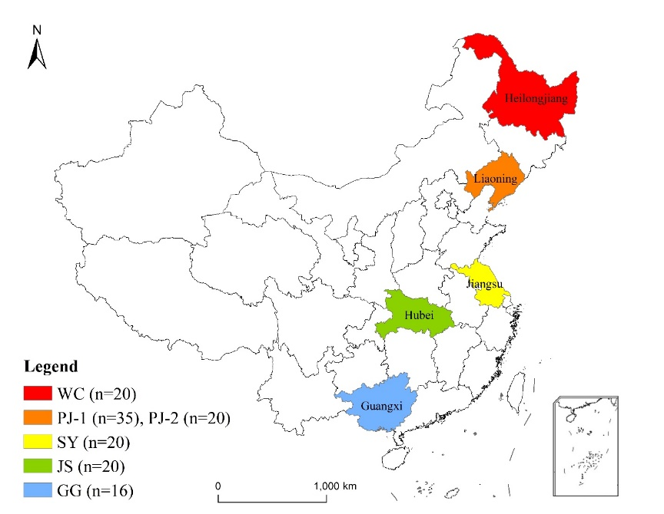

(a)

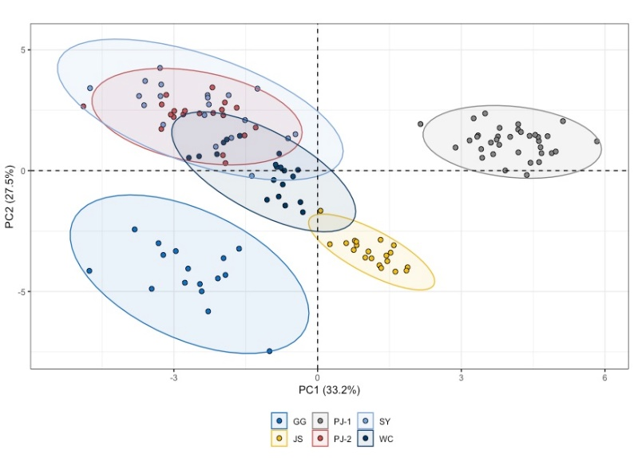

(b)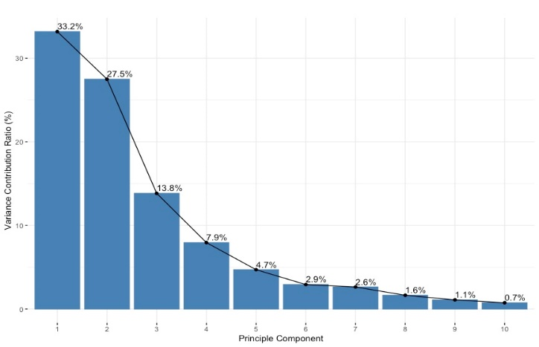(c)

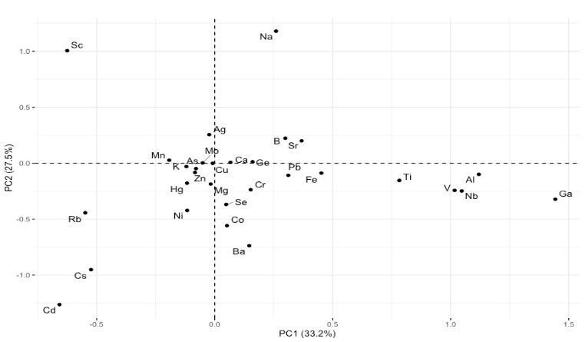

Fig.2.PCA on elemental concentration based on 30 variables in six GI rice: (a) Score plot of PC1 and PC2, with 95% confidence interval eclipse; (b) Distribution of variance contribution ratio of first ten PC (c) Loading plot of all variables on first two PCs.

Fig. 3. Relative variable importance based on Relief algorithm .

Fig. 4. The construction of Two-dimensional matrix for Grid-search. Each grid represent different feature subset-hyperparameter combination.

Fig. 5. RGSCV results on Chinese GI rice dataset using RF, and SVM, with different number of selected features

·